MongoDB & Vault :

Both has the following applications & profiles : gateway,myapp / dev,prod

# Request : 1 (one application / one profile)

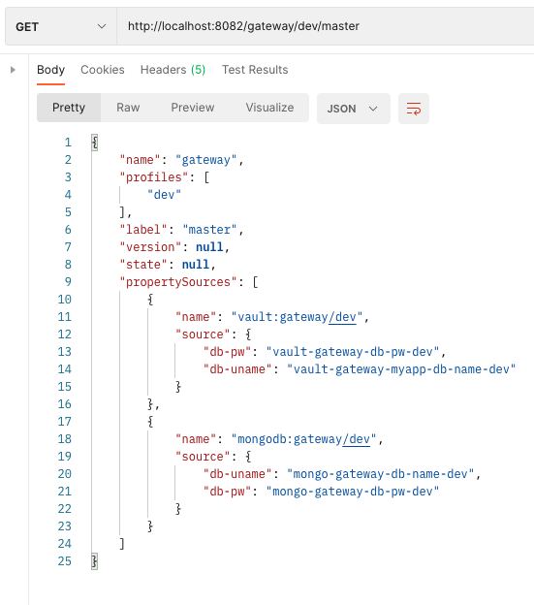

Request: 2: One application + two profiles

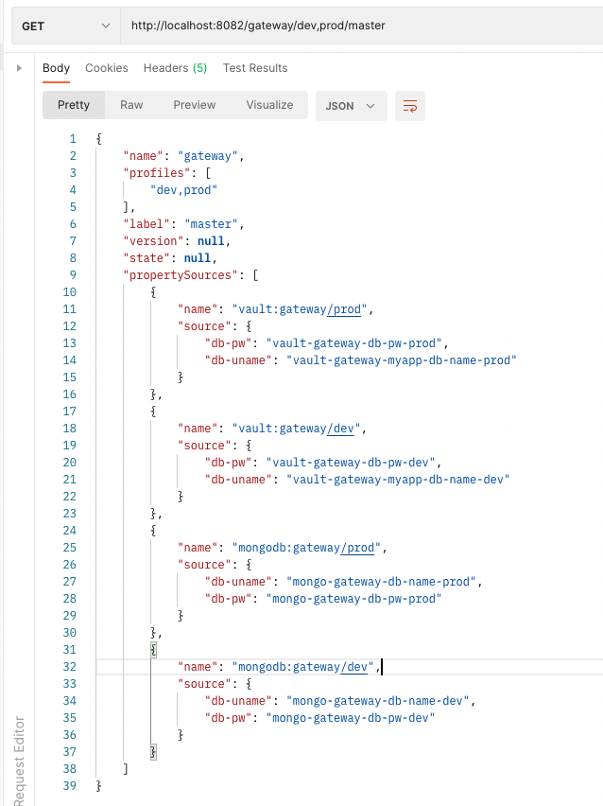

Request:3 (two applications , one profile)

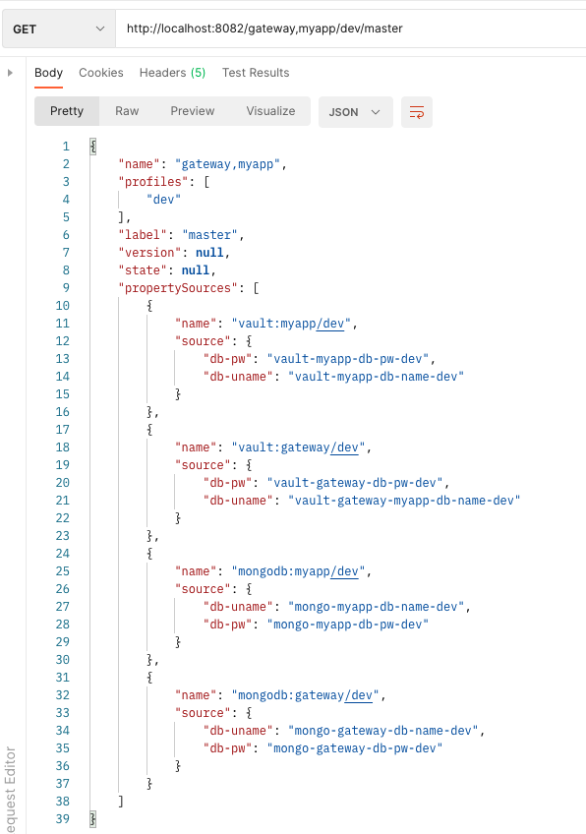

Request 4 ( Two applications , two profiles)

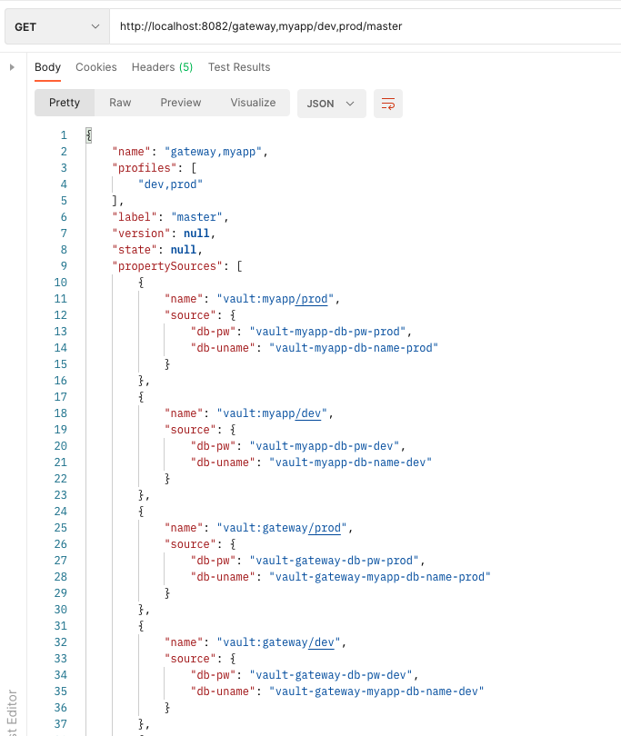

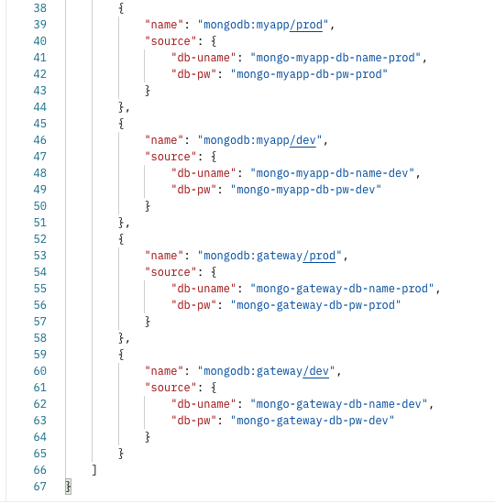

Config-client:

config-client project - application.properties

